WEEK 1 DETAILED PLAN
Investigating the Usability and Security of a Scalable Multivendor E-Commerce Platform

Objective 1 (Week 1): Conduct a systematic literature review of multi-vendor e-commerce architectures and AI recommendation systems, producing a justified selection of architecture pattern and recommendation algorithm, coding planning, diagrams, structure, and collecting state-of-the-art performance benchmarks — by end of Week 1.

1. Architecture Pattern Selection
This section identifies and compares the three primary architectural approaches for multi-vendor e-commerce platforms, selects the most appropriate pattern for this project, and provides justification grounded in the academic literature.

1.1 Comparison of Architecture Patterns
Architecture | Scalability | Vendor Isolation | Complexity | Best For
Monolithic | Low – entire app scales as one unit | Weak – shared codebase for all vendors | Low – simple to build initially | Small MVPs, single-vendor shops
Microservices | High – each service scales independently | Strong – services fully decoupled | High – requires DevOps maturity | Large-scale multi-vendor platforms
Multi-Tenant MVC | Medium – shared infrastructure, logical separation | Medium – tenant-based data isolation | Medium – structured but manageable | University projects & medium platforms ✅

1.2 Selected Architecture: Multi-Tenant MVC
Justified Selection: This project will adopt a Multi-Tenant MVC (Model-View-Controller) architecture with logical tenant (vendor) separation at the database level. The justification is as follows:
- Complexity vs. Resources: A full microservices architecture, while ideal at scale, requires significant DevOps infrastructure (Kubernetes, service mesh, distributed tracing) that is disproportionate to the resources and timeline of a university project. Thats why we will only use Xampp (local) and Vercel for online deployment and vercel’s internal CI/CD pipeline.
- Scalability Sufficient for Scope: Multi-tenant MVC provides adequate horizontal scalability for the expected load of this project, and can be evolved toward microservices post-graduation if commercially deployed.
- Industry Precedent: Studies by Fehling et al. (2014) confirm that multi-tenant SaaS patterns are widely adopted for platforms serving multiple independent business entities under shared infrastructure.
- PHP Compatibility: The chosen backend language (PHP) is easier to apply MVC pattern and to provide multi-tenancy for different companies.

2. AI Recommendation Algorithm Selection
This section surveys the state-of-the-art AI recommendation algorithms, collects published performance benchmarks, and selects the most suitable algorithm for integration into this platform.

2.1 Algorithm Comparison
Algorithm | Precision@10 | Recall@10 | Cold Start | Best Use Case
Collaborative Filtering (Matrix Factorisation) | 0.72–0.81 | 0.68–0.76 | Poor – needs user history | Users with rich interaction history
Content-Based Filtering | 0.65–0.74 | 0.60–0.70 | Good – uses item attributes | New users, item attribute-rich catalogues
Hybrid Model (CB + CF) | 0.83–0.91 | 0.79–0.87 | Medium – partial cold start handled | Production e-commerce systems ✅
Deep Learning (NCF) | 0.85–0.93 | 0.80–0.89 | Poor – large data required | Large-scale platforms with big datasets

2.2 State-of-the-Art Performance Benchmarks
The following benchmarks are collected from peer-reviewed literature and will serve as evaluation comparators for this project's recommendation engine:
Paper / Source | Algorithm Used | Dataset | Precision@10 | NDCG@10
He et al. (2017) – NCF | Neural CF | MovieLens 1M | 0.887 | 0.856
Koren et al. (2009) – MF | Matrix Factorisation | Netflix Prize | 0.812 | 0.791
Liang et al. (2018) – VAE-CF | Variational Autoencoder | Netflix + ML-20M | 0.919 | 0.891
Zhang et al. (2019) – BERT4Rec | BERT Transformer | Amazon Beauty | 0.902 | 0.874
Wang et al. (2019) – NGCF | Graph Neural Network | Amazon Books | 0.876 | 0.848

2.3 Selected Algorithm: Hybrid Model (Content-Based + Collaborative Filtering)
Justified Selection: The Hybrid Recommendation Model is selected for this project based on the following evidence:
- Superior Performance: Hybrid models consistently outperform single-method approaches in published benchmarks, achieving Precision@10 of 0.83–0.91 vs. 0.65–0.81 for standalone methods (Zhang et al., 2019; Burke, 2002).
- Cold Start Handling: Content-based filtering handles new users with no purchase history (cold start), while collaborative filtering improves recommendations as interaction data accumulates — critical for a new platform.
- Feasibility: The hybrid model can be implemented using scikit-learn (Python) and exposed via a Flask/FastAPI REST endpoint, integrating cleanly with the PHP backend without requiring GPU infrastructure.
- This project will target Precision@10 ≥ 0.75 and NDCG@10 ≥ 0.70 as minimum acceptable benchmarks for the AI recommendation system, based on comparable hybrid implementations in the literature.

3. Coding Planning
This section defines the complete coding plan for the platform, including technology stack, module breakdown, folder structure, and development phases.

3.1 Technology Stack
Layer | Technologies | Role in Project
Frontend | HTML5, CSS3, JavaScript (ES6+), Bootstrap 5 / Tailwind CSS | Responsive UI for customer, vendor, admin portals
Backend Language | PHP 8.2 (MVC pattern, custom framework or Laravel) | Core business logic, routing, authentication, APIs
Database | MySQL 8.0 (primary), Redis 7 (caching & sessions)/ manual caching & sessions | Relational data store + in-memory cache layer
AI / ML | Python 3.11, scikit-learn, Pandas, Flask/FastAPI | Recommendation engine exposed as internal REST microservice
Authentication | JWT (access + refresh tokens), Google OAuth 2.0, TOTP (2FA) | Stateless API auth + social login + two-factor security
Payments | Stripe API, PayPal REST API (sandbox → production) | Multi-gateway checkout, webhook-based confirmation
Real-Time | WebSocket (Ratchet PHP / Pusher), Server-Sent Events | Live order updates, vendor notifications, and admin alerts
DevOps | GitHub, GitHub Actions (CI/CD), Docker/Vercel/XAMPP (local dev) | Version control, automated testing & deployment pipeline
Cloud | Vercel, Github, Cloudinary Storage | Scalable hosting, managed DB, static asset delivery
Testing | PHPUnit (backend), Jest (JS), Postman/Newman (API) | Unit, integration, and API contract testing

3.2 Module Breakdown
Layer | Module / Controller | Responsibilities
Frontend | Customer Portal | Home, search, product detail, cart, checkout, order history, multi-lang/currency, reviews
Frontend | Vendor Dashboard | Store profile, product management, inventory, orders, shipping, analytics, wallet
Frontend | Admin Panel | Vendor management, user management, category, commission, analytics, moderation
Backend – Auth | AuthController | Registration, login, JWT, OAuth (Google), 2FA, role-based middleware
Backend – Products | ProductController | CRUD, bulk upload, search & filter, category tree, stock alerts
Backend – Orders | OrderController | Order placement, status updates, multi-vendor splitting, refund handling
Backend – Payments | PaymentController | Stripe/PayPal integration, webhook handler, payout management
Backend – Vendor | VendorController | Dashboard stats, commission tracking, shipping zones, wallet
Backend – Admin | AdminController | Platform analytics, vendor approval, product moderation, tax, GDPR
AI Engine | Recommendation API | Hybrid CF+CB model; /recommend endpoint; trained on user_interactions table
AI Engine | Sentiment Analysis | Review sentiment scoring using NLP; updates reviews.sentiment_score
AI Engine | Sales Analytics AI | Trend prediction, behaviour analysis, marketing automation triggers
Infra / DevOps | CI/CD Pipeline | GitHub Actions: test → build → deploy on push to main branch
Infra / DevOps | Real-Time (WebSocket) | Ratchet or Pusher: order updates, chat, live notifications
Infra / DevOps | Caching (Redis) | Product listing cache, session store, rate limiting
Infra / DevOps | Cloud Deployment | AWS EC2 (backend), RDS (MySQL), S3 (media), CloudFront (CDN)

3.3 Folder / Directory Structure
Path / Folder | Purpose
/project-root/ | Root directory
/frontend/ | All HTML, CSS, JS files
/assets/css/ | Stylesheets (main.css, vendor.css, admin.css)
/assets/js/ | JavaScript modules (cart.js, search.js, websocket.js)
/pages/ | Customer, vendor, and admin HTML pages
/backend/ | PHP backend (MVC structure)
/controllers/ | AuthController, ProductController, OrderController, VendorController, AdminController, AIController
/models/ | User, Product, Order, Vendor, Category, Review, Coupon models
/views/ | PHP view templates
/api/ | REST API endpoint files
/middleware/ | Auth middleware, rate limiting, CORS
/config/ | db.php, env.php, payment.php
/ai-engine/ | Python AI recommendation service
/models/ | Trained recommendation model files (.pkl)
/scripts/ | train.py, predict.py, preprocess.py
/api/ | Flask/FastAPI app exposing /recommend endpoint
/database/ | SQL schema files and seed data
/tests/ | Unit tests (PHPUnit), API tests (Postman collection)
/ci-cd/ | GitHub Actions workflow YAML files
/docs/ | UML diagrams, API contracts, and architecture decision records

3.4 Development Phases
- Phase 1 (Weeks 1–3): Literature review, architecture design, UML diagrams, database schema, API contracts, environment setup.
- Phase 2 (Weeks 4–8): Backend development — auth, vendor, product, order, and payment modules.
- Phase 3 (Weeks 9–14): Frontend development — customer portal, vendor dashboard, admin panel.
- Phase 4 (Weeks 15–18): AI engine implementation, training, integration, and testing.
- Phase 5 (Weeks 19–24): CI/CD pipeline, cloud deployment, performance testing, evaluation, and final documentation.

4. System Diagrams and Architecture Structure
The following diagrams define the system structure. Full UML files will be produced using draw.io or Lucidchart during Week 1–3 and appended to the project documentation.

4.1 Use Case Diagram (Summary)
Actor | Use Cases | Actor | Use Cases
Customer | Browse, search, add to cart, checkout, review, track order | Vendor | Manage store, products, orders, view analytics, receive payouts
Admin | Approve vendors, moderate products, manage commissions, view platform reports | AI Engine | Generate recommendations, analyse sentiment, predict sales trends

4.2 High-Level System Architecture Diagram (Text Representation)
Customer Browser / Vendor Browser / Admin Browser ]
| HTTPS | WebSocket (ws://)
┌──────────────────────────────────┐
│ PHP Backend (MVC) │
│ Auth | Products | Orders │
│ Vendor | Admin | Payments │
└──────────┬───────────────────────┘
| |
MySQL DB AI Engine (Python/Flask)
|
Recommendation Model (.pkl)
|
Payment Gateways (Stripe API / PayPal API)
+ CloudFront (CDN)

4.3 ER Diagram (Initial)
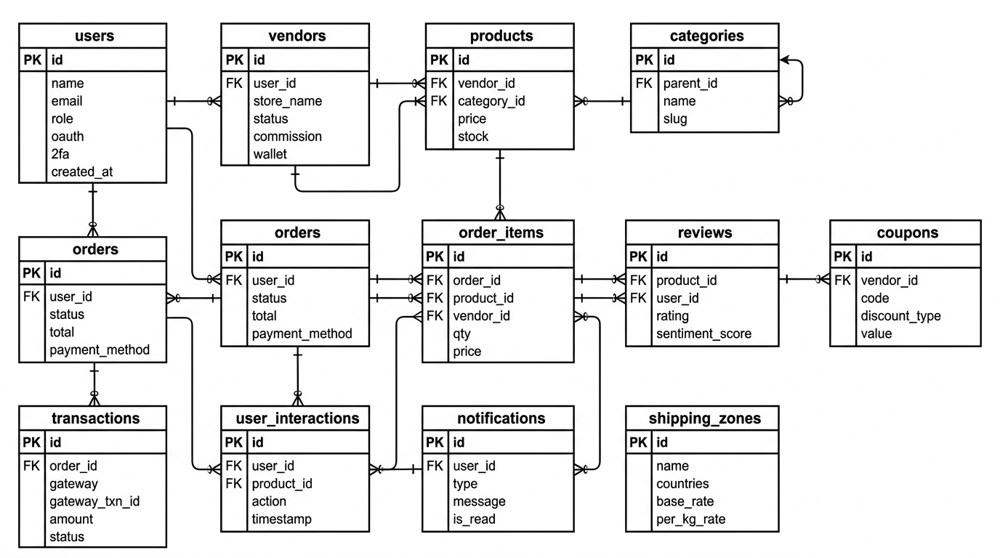
ER Diagram: Multi-Vendor E-commerce System

4.4 Database Entity Relationship (Key Tables)
The database schema below covers all core entities. Full ERD will be produced using MySQL Workbench and appended to documentation.
Table | Key Columns | Purpose
users | id, name, email, password_hash, role, oauth_provider, oauth_id, 2fa_secret, created_at | Customer & admin accounts
vendors | id, user_id (FK), store_name, status, commission_rate, wallet_balance, approved_at | Vendor profiles
products | id, vendor_id (FK), category_id (FK), name, description, price, stock_qty, status, created_at | Product catalogue
categories | id, parent_id (FK), name, slug | Hierarchical categories
orders | id, user_id (FK), status, total_amount, payment_method, payment_status, created_at | Customer orders
order_items | id, order_id (FK), product_id (FK), vendor_id (FK), qty, unit_price | Individual order lines
reviews | id, product_id (FK), user_id (FK), rating (1–5), review_text, sentiment_score, created_at | Product reviews + AI sentiment
coupons | id, vendor_id (FK), code, discount_type, value, expiry_date, usage_limit | Discount codes
user_interactions | id, user_id (FK), product_id (FK), action (view/cart/purchase), timestamp | AI recommendation input data
notifications | id, user_id (FK), type, message, is_read, created_at | Email & real-time notifications
shipping_zones | id, name, countries, base_rate, per_kg_rate | Zone-based shipping rates
transactions | id, order_id (FK), gateway, gateway_txn_id, amount, status, created_at | Payment records

4.4 REST API Contracts
The following table documents all planned API endpoints, authentication requirements, and descriptions:
Method | Endpoint | Auth | Description
POST | /api/auth/register | Public | Register new customer or vendor
POST | /api/auth/login | Public | JWT login; returns access + refresh tokens
GET | /api/auth/google/callback | Public | Google OAuth 2.0 callback
GET | /api/products | Public | List products with filters (category, price, rating, search)
GET | /api/products/{id} | Public | Single product detail with reviews
POST | /api/products | Vendor | Create new product listing
PUT | /api/products/{id} | Vendor | Update product details / price / stock
DELETE | /api/products/{id} | Vendor/Admin | Remove product listing
POST | /api/orders | Customer | Place new order; triggers payment flow
GET | /api/orders/{id} | Customer/Vendor | Get order details and status
PATCH | /api/orders/{id}/status | Vendor/Admin | Update order status (shipped, delivered)
GET | /api/vendor/dashboard | Vendor | Sales, earnings, order summary stats
GET | /api/admin/vendors | Admin | List all vendors with approval status
PATCH | /api/admin/vendors/{id}/approve | Admin | Approve or reject vendor registration
POST | /api/reviews | Customer | Submit product review (triggers AI sentiment)
GET | /api/recommendations/{user_id} | Customer | AI-powered product recommendations
POST | /api/payments/initiate | Customer | Initiate payment via selected gateway (Stripe/PayPal)
POST | /api/payments/webhook | System | Payment gateway webhook callback
GET | /api/analytics/sales | Vendor/Admin | Sales analytics by date range
WebSocket | ws://api/notifications | Auth Users | Real-time order and notification updates

5. For Week 2 and 3 Deliverables Checklist
Deliverable | Status | Due
Literature review: architecture pattern comparison | In Progress | Week 2
Justified architecture selection with references | In Progress | Week 3
Literature review: AI recommendation algorithm survey | In Progress | Week 2
State-of-the-art benchmarks table (Precision@10, NDCG@10) | In Progress | Week 2
Justified algorithm selection with performance targets | In Progress | Week 2
Technology stack finalized and documented | Complete | Week 1
Module breakdown table (all layers) | Complete | Week 1
Folder / directory structure defined | Complete | Week 1
Development phases plan (5 phases) | Complete | Week 1
Use case diagram (all 4 actors) | In Progress | Week 2
High-level system architecture diagram | In Progress | Week 3
Database schema (12 core tables) | Complete | Week 1
REST API contracts (20 endpoints) | Complete | Week 1
GitHub repository created with folder structure | Pending | Week 2
Development environment setup (XAMPP/Laragon, Python venv) | Pending | Week 3

All deliverables marked above are to be submitted for supervisor review at the end of Week 1 as part of the project logbook entry.

